# Performance evaluation

Here should be an introduction of what we will test (the emulator and/or the protocol).

## Requirements

Here should be a list of all requirement that should be tested and criteria for passed not passed.

Requirements:

Emulator

Amount of users (CPU,RAM)

Configurability (channel, number of UEs, etc.)

Power control

Massiveness

Time to connect vs. connection request per second

Data rate vs. number of users

Spectrum use vs. number of users

Interference level vs. number of users

Power

Energy consumption for attach.

Energy consumption vs. data rate

Energy consumption vs. coverage level

Energy consumption vs. operation mode

Energy consumption vs. number of UEs

Energy consumption vs. UE state (Connected (cDRX), eDRX, PSM, Off)

## Test setup

Here should be a description of the general setup (including figure) used in all test and a list of baseline values for all parameters. Including physical setup, BSE, UEE.

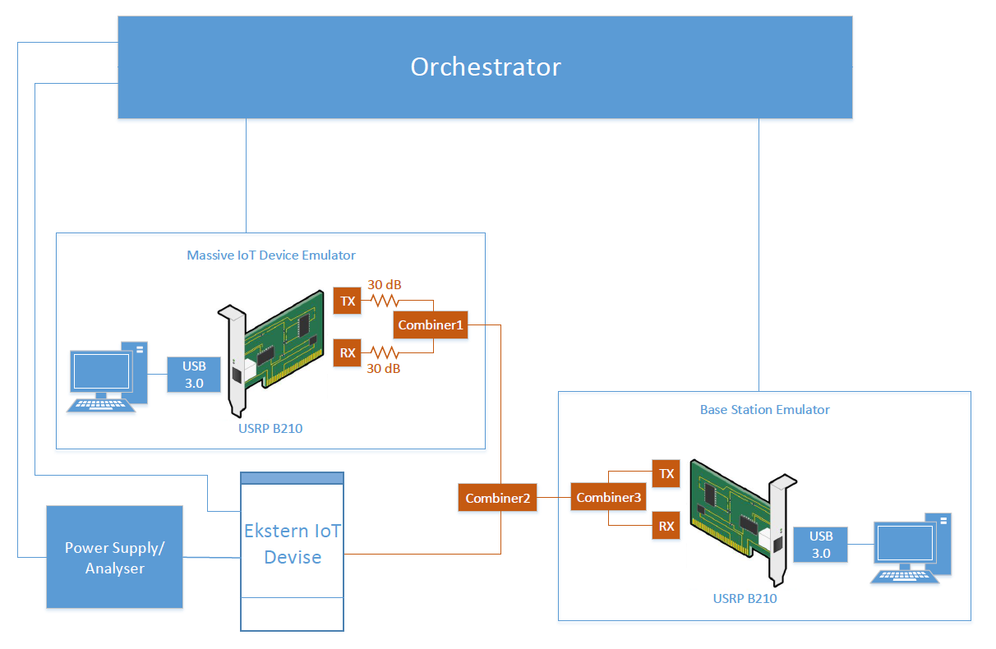

|  |  |
| --- | --- |
| **Massive IoT Emulator** | |
| Parameter | Value |
| Number of devices | 0 |
| Rx gain | 40 dB |
| Tx gain | 40 dB |
| R14 | False |
| Dl_EARFCN | 6310 |
| UE_category | Nb1 |
| **Power Supply/Analyser** | |
| Enable | Off |
| Volt | 3.6 V |
| Ampere | 1 A |
| **Ekstern IoT device** | |
| Enable | Off |
| Dl_EARFCN | 6310 |
| **Base Station Emulator** | |
| Cell type | NB-IoT |
| Number of cells | 1 |
| Operation mode | Standalone |
| Dl_EARFCN | 6310 |
| Cell ID | 0 |
| Tx gain | 89 dB |
| R14 | False |
| nprach_detect_threshold | 19 dB |

## Test procedure

Here should be a step by step procedure of all test for all requirements, maybe put tapplans in appendix.